Universally poor' salmon fishing season

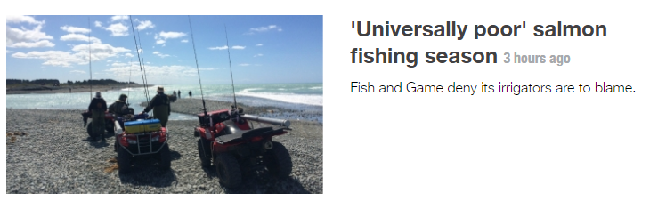
- 3 hours ago
- By Newshub staff
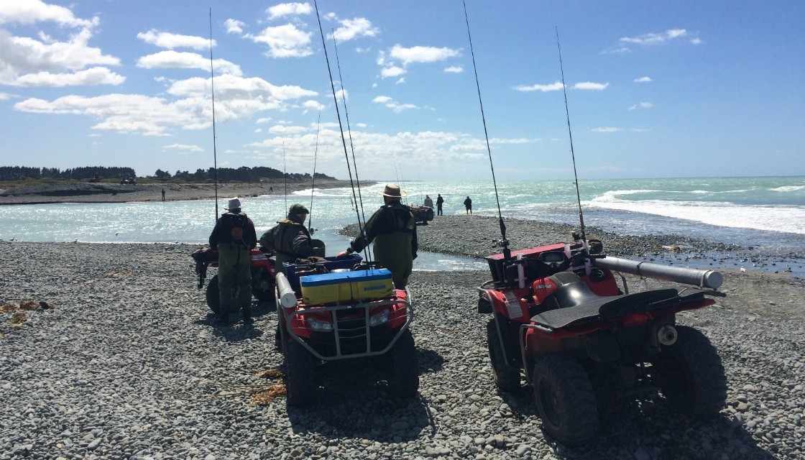

Anglers on the Rangitata River (Thomas Mead/Newshub)
Concerns are being raised over why only a handful of salmon have been caught this season in the Rangitata River near Ashburton in Canterbury.
At this time of the season, the normal tally of catches is around 200. But so far, only 25 have been caught.
Fish and Game's Mark Webb says there is a problem out at sea that is causing low rates of catches across the South Island.
"All of the main fisheries on the east coast of the South Island are in a similar predicament," he says.
"The fact all the fisheries are affected to the same extent suggests that whatever it is that is controlling salmon numbers is happening when they're all in the same environment.
"The only place that happens is when they're at sea."
Local fisher Pete Ritchie disagrees saying it is because of the development of irrigation channels.
"Eighty years I've fished this river and I've never, ever seen it so bad," he says.
"It's time something gets done about the irrigators."
He says it's affecting the whole community.
"With the 15,000 or 18,000 licence holders, it's worth millions of dollars a year," he says.
"It's not affecting us as fishermen, it's affecting all the hotels, motels, service stations, supermarkets, everybody gets affected if there's no fish in the river."
Fish and Game say rates can fluctuate from season to season, saying three seasons since 2000 netted less than 150 salmon.
Tests have been carried out by Fish and Game to determine why catch rates aren't as high as they'd like.
Newshub.

